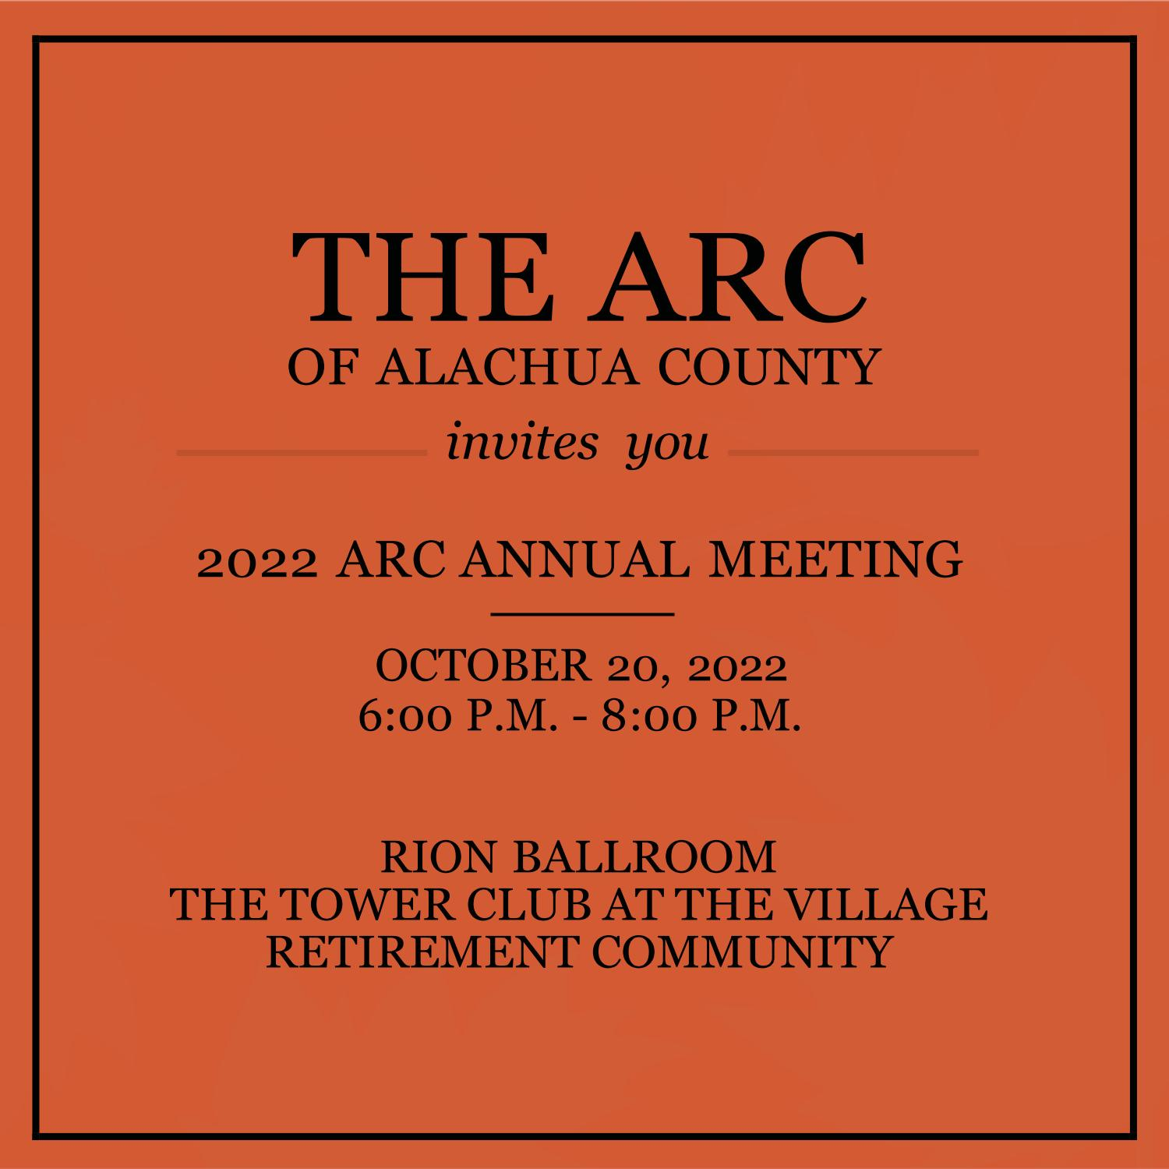
2022 Arc Annual Meeting & Recognition Event Ticket & Sponsorship Agreement

The 2022 Arc Annual Meeting & Recognition Event takes place on Thursday, October 20, 2022 from 6 p.m. until 8 p.m. in the Rion Auditorium at The Tower Club, The Village Retirement Community. You are responsible for payment of the tickets or sponsorships chosen by October 19, 2022.

- Call Dr. Mark A. Johnson at 352-246-3516 to make payment via credit card using SQUARE swipe.
- Make payment via check by mailing check payable to ‘Arc of Alachua County’ to Mark Johnson, Arc of Alachua County, 3303 NW 83rd St., Gainesville, FL, 32605. Place phrase ‘annual meeting’ in memo line.
- Pay by having an invoice sent to my business or company by sending Mark Johnson an email at mjohnson@arcalachua.org with 1. Business name, 2. Business address, 3. Contact person at business, 4. Amount or Level of sponsorship. Dr. Johnson will send your business’ contact person an invoice within 2-3 business days.

Statement of Sponsorship/Ticket Purchase: “I agree to purchase the sponsorship(s) or ticket(s) checked below and agree to pay the associated fee noted by Wednesday, October 19, 2022.”
Name: ________________________________ Date: _______

2022 ARC ANNUAL MEETING & RECOGNITION EVENT SPONSORSHIP LEVELS

- GOLD LEVEL: $2,000 (14 guests)
- SILVER LEVEL: $1,500 (12 guests)
- BRONZE LEVEL: $1,000 (10 guests)

2022 ARC ANNUAL MEETING & RECOGNITION EVENT TABLE SPONSORSHIP

- $750 for 1 Table (8 guests)

2022 ARC ANNUAL MEETING & RECOGNITION EVENT TICKET(S) PURCHASE

- $75 per person (1 Guest) Please identify: Number of Tickets: _____ Total Price @ $75 Per Ticket: _____

2022 ARC INDIVIDUAL AWARD SPONSORSHIP LEVELS

- $1,000 for Employee of the Year (6 Guests)
- $500 for Client of the Year (6 Guests)
- $500 for DSP of the Year (6 guests)

